Global Asset Performance and Portfolio Optimization (2015–2024):

Objective

This project studies how five major global assets, Crude Oil (CL=F), Gold (GC=F), FTSE 100 (^FTSE), S&P 500 (^GSPC), and Nifty 50 (^NSEI), have performed and interacted with each other over the last decade, from 2015 to 2024.
The main aim was to understand how these assets move together, how much risk and return they offer individually, and how they can be combined to form an optimal portfolio that balances risk and reward effectively.
All the data was sourced from Yahoo Finance (yfinance), and the analysis was done using Python, mainly with libraries like Pandas, NumPy, and SciPy for cleaning, analysis, and statistical testing.
To manage the data efficiently, I stored it in MySQL, and finally, I built an interactive Power BI dashboard to visualize trends, relationships, and portfolio performance in a simple and insightful way.

The figure below shows the cumulative performance of the five major global assets, Nifty 50, S&P 500, FTSE 100, Gold, and Crude Oil, from 2015 to 2024.

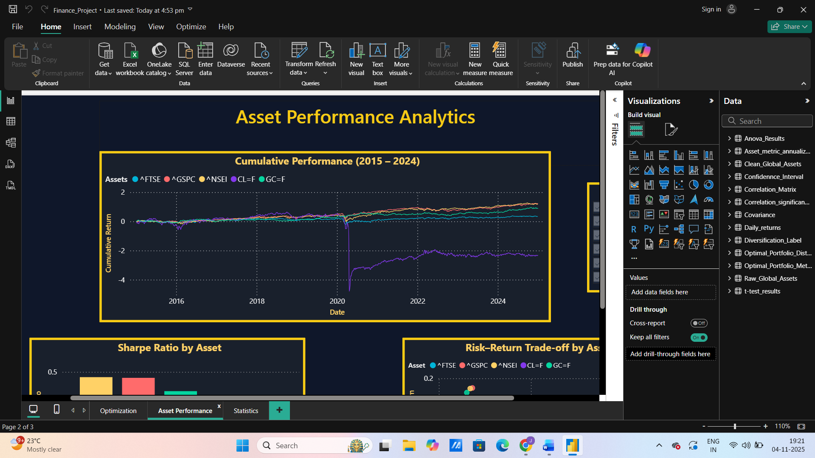

Methodology

I used a combination of statistical tools and portfolio optimization techniques to explore how these assets behave over time and how they can be best combined. The steps included:
- ANOVA (Analysis of Variance) to compare mean returns across assets,
- Correlation analysis and significance testing to understand how closely the markets are linked,
- Confidence intervals to measure how stable or uncertain the average daily returns are, and
- Sharpe ratio and mean–variance optimization to design the most efficient mix of assets.
All calculations were performed using Python, Pandas for data handling, NumPy for calculations, and SciPy for statistical tests and optimization models. The final results were stored in MySQL and visualized in Power BI, where I created dashboards showing return trends, risk measures, and portfolio allocations.

Key Findings

1. Annualized Performance

- The S&P 500 and Nifty 50 were the top performers, delivering high returns with strong risk-adjusted scores (Sharpe ratios).
- Gold maintained its traditional role as a safe-haven asset, its returns were modest, but it remained stable even during market turbulence.
- Crude Oil, on the other hand, was the most volatile and underperformed, heavily affected by events like the COVID-19 pandemic and the Russia–Ukraine conflict.
- In short, equities gave growth, gold added safety, and oil brought diversification but with higher risk.

2. Correlation and Market Linkages

- The FTSE 100, S&P 500, and Nifty 50 showed moderate to strong correlations, suggesting that global equity markets have become more interconnected, especially after 2020.
- Gold stood apart with weak correlations to stocks, proving its worth as a hedge during volatile periods.

3. ANOVA and Confidence Intervals

- The ANOVA test showed no statistically significant difference in mean returns among the five assets (p = 0.543), suggesting that average returns are broadly comparable despite differences in volatility.
- The confidence intervals provided further context, Nifty 50 and S&P 500 displayed narrow and positive return bands, indicating stable and consistent performance, while Crude Oil had a wide range, reflecting high uncertainty and erratic price movements.

4. Portfolio Optimization

- The optimized portfolio allocated approximately 35% each to Nifty 50 and Gold, and 30% to S&P 500, with negligible weights to FTSE and Oil.
- This combination achieved an expected annual return of 11.72%, volatility of 10.79%, and a Sharpe ratio of 0.62, marking it as an efficient and well-balanced portfolio.
- The optimization outcome aligns with recent market behaviour, where resilient equity markets (India, U.S.) and defensive assets (Gold) have collectively provided strong long-term stability.

The following chart displays the optimized asset allocation, highlighting the relative weights of each asset in the efficient portfolio.

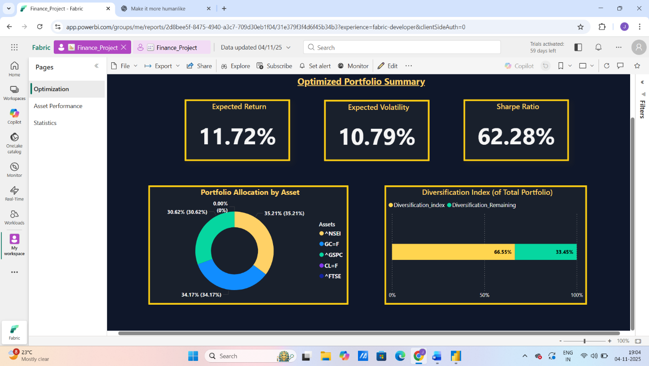
Conclusion
The study highlights how blending growth-oriented equities with safe-haven assets can enhance portfolio efficiency. While Oil and FTSE offer limited diversification advantages, they still hold tactical value under shifting macroeconomic conditions.
In essence, a portfolio combining Nifty 50, S&P 500, and Gold stands out as a robust allocation strategy in an increasingly interconnected yet uncertain global market.

